ASSIGNMENT 2

1. Database Design (Normalization):

1. Create the database named "SISDB”

CREATE DATABASE SSIDB;

2. Define the schema for the Students, Courses, Enrollments, Teacher, and Payments tables based on the provided schema.

create database SSIDB;

use SSIDB;

create table Students (

student_id int primary key,

first_name varchar(50),

last_name varchar(50),

date_of_birth date,

email varchar(100),

phone_number varchar(15)

);

create table Courses (

course_id int primary key,

course_name varchar(100),

credits int,

teacher_id int,

foreign key(teacher_id) references Teachers(teacher_id)

);

create table Enrollments (

enrollment_id int primary key,

student_id int,

course_id int,

enrollment_date date,

foreign key(student_id) references Students(student_id),

foreign key (course_id) references Courses(course_id)

);

create table Teachers (

teacher_id int primary key,

first_name varchar(50),

last_name varchar(50),

email varchar(100)

);

create table Payments (

payment_id int primary key,

student_id int,

amount decimal(10, 2),

payment_date date,

foreign key(student_id) references Students(student_id)

);

3. Perform the first three normal forms (1NF, 2NF, 3NF) analysis on the above tables.

1. First Normal form:

All tables are already in 1NF and they don’t contain any repeating groups.

Each table has a primary key and which is uniquely identify each record.

1. Second Normal form:

A table is in 2NF if it is in 1NF and non prime attributes are fully functionally dependent on primary key

The Courses table has a partial dependencies on the primary key because the “teacher_id” is functionally dependent on part of the primary key “course_id”.

Teachers Table

create table Teachers (

teacher_id int primary key,

first_name varchar(50),

last_name varchar(50),

email varchar(100)

);

Course table – updated into 2NF

create table Courses (

course_id int primary key,

course_name varchar(100),

credits int,

teacher_id int,

foreign key(teacher_id) references Teachers(teacher_id)

);

“teacher_id” is fully functionally dependent on the primary key of the Teacher table

3.Third Normal Form:

A table is in 3NF if it is in 2NF, and no transitive dependencies

create table Enrollments (

enrollment_id int primary key,

student_id int,

course_id int,

enrollment_date date,

foreign key(student_id) references Students(student_id),

foreign key (course_id) references Courses(course_id)

);

Here All the tables are in 3NF

1. Create an ERD (Entity Relationship Diagram) for the database:

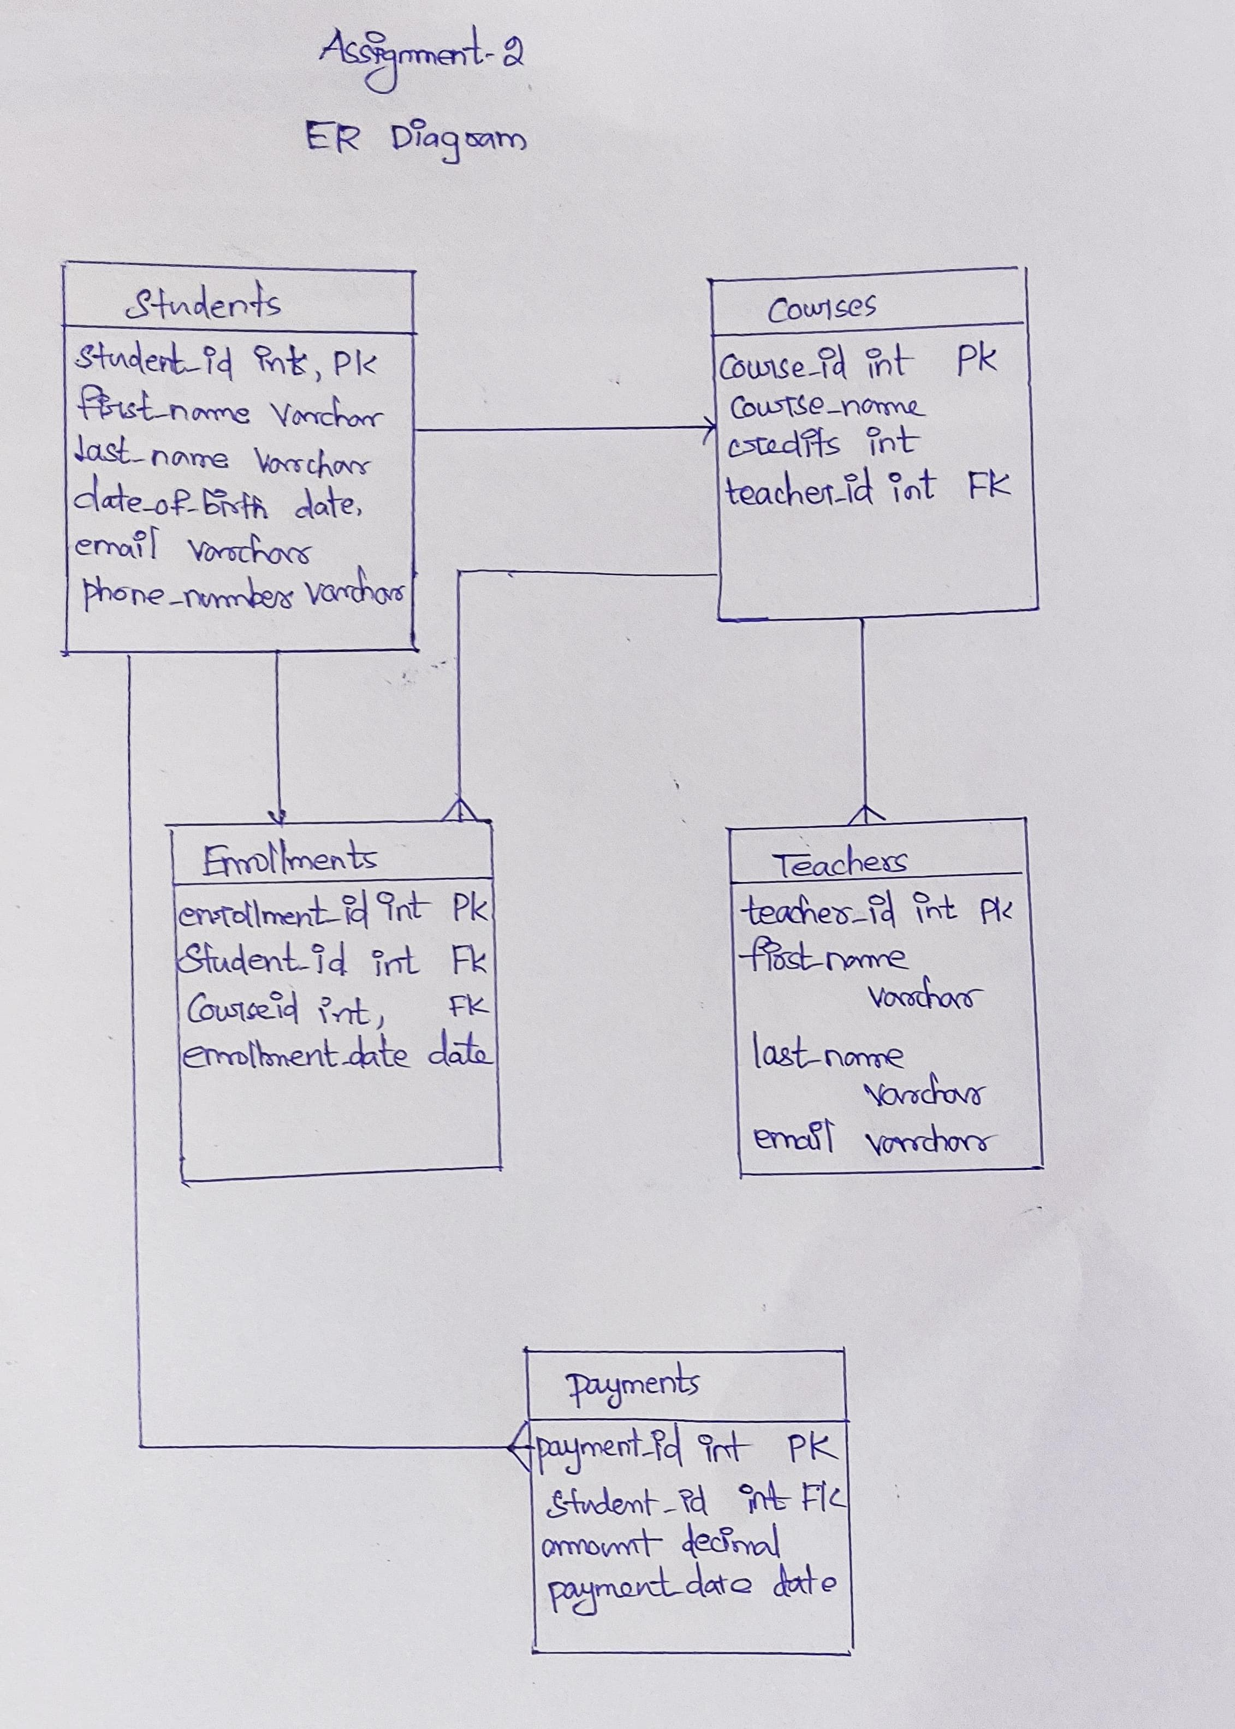

One to many relationship between Students and Enrollments

One to many relationship between Courses and Enrollments

Many to one relationship between Teachers and Courses

One to many relationship between Studemts and payments